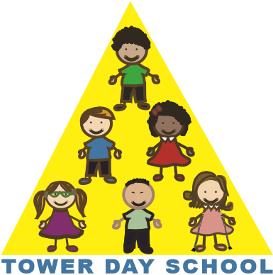

Tower Day School

Application Form

2021/2022

Child’s Name: _______________________________________________________________

Date of Birth: _______/______/__________ Sex: M_______F_______

Parent’s Name: ______________________________________________________________

Home Address: ______________________________________________________________
Street Town Zip

Phone: _______________________Email:_________________________________________

Name(s) of any sibling(s) who have previously attended Tower Day School:

___________________________________________________________________________

Please number your class choices in order of preference.

3-year-old class options 4-year-old class options

___ T,TH class (8:30 - 11:30 am) ___ M,W,F class (8:30 - 11:30 am)

___ M,W,F class (8:30 - 11:30 am) ___ M - F class (8:30 - 11:30 am)

___ M,W,F full day class (8:30 am - 2:30 pm)

___ T,W,TH full day class (8:30 am - 2:30 pm)
Transition class

___ M,W,F (8:30 - 11:30 am) and T,TH (8:30 am - 2:30 pm)

Early Drop-off and Extended Day Program options will be included on your Confirmation Form

_________ Yes, I have read the attached Application Form Information.

Signature____________________________________________Date____________________

Please return this form with your $75.00 (per family)
non-refundable application fee.
Please make checks payable to: Tower Day School

5 Summer Street, Lynnfield, MA 01940 towerdayschool@gmail.com 781.334.5576 www.towerdayschool.org

